iKhaya le Themba
Volunteers
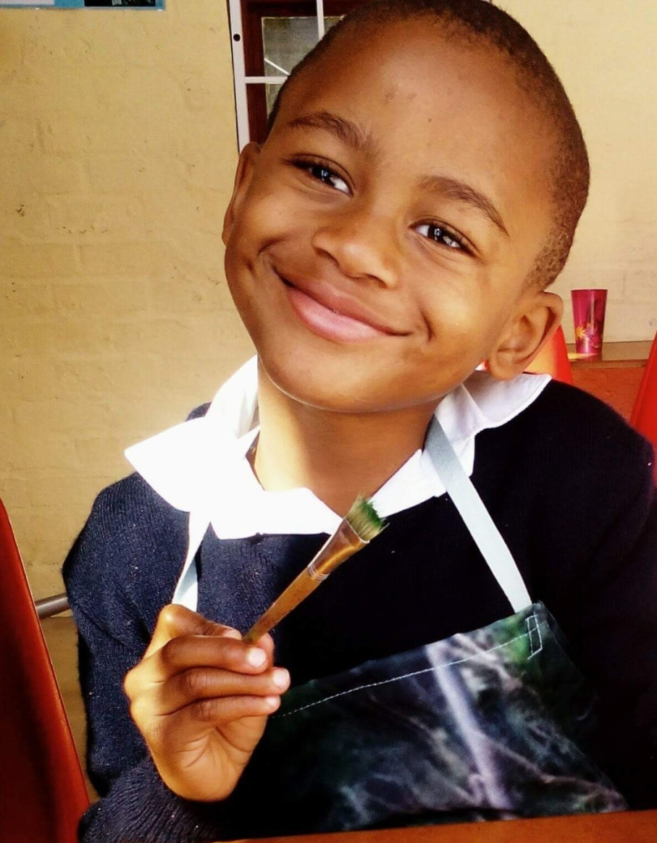
iKhaya le Themba (Home of Hope)
Erf 2843, Van Hoogstraten Street,
Imizamo Yethu, Hout Bay, Cape Town

Content

iKhaya le Themba 3
Volunteer at iKhaya le Themba 3
What iKhaya offers their volunteers 3
Volunteer role 4
Information 5
Application 9
Application form – volunteer registration 2023 10
Child Abuse and Neglect 12

iKhaya le Themba

iKhaya le Themba – Home of Hope – is a registered NPO in the heart of the township of Imizamo Yethu in Hout Bay. We began our work in 2003 and have built capacity to a point where we now serve 100 orphaned and vulnerable children between the ages of 6 and 12 years old who attend our after-school care program, Monday to Friday, 1:30pm to 5:30pm.
These children are orphaned and vulnerable due to poverty, HIV/AIDS, learning difficulties and emotional trauma. iKhaya le Themba offers holistic care and support to these children, their families and carers in the local community of Imizamo Yethu situated in Hout Bay, Cape Town, South Africa.

Volunteer at iKhaya le Themba

iKhaya le Themba is a non-profit organisation located in the township of Imizamo Yethu in Hout Bay. Volunteers are great assets to iKhaya as they help with activities, act as mentors, older brothers and sisters from other nations to the children. By volunteering at iKhaya you are participating in responsible and sustainable tourism.
There are two ways you can start your volunteering journey at iKhaya. If you don’t like to arrange a lot of affairs by yourself you might prefer to come in through a volunteer organisation. We have contact details and they can arrange your stay in South Africa. There are also people who would like to save a lot of money and come into iKhaya on their own, this is why we offer our own service to volunteers who want to be in direct contact with us. We do ask for a small donation of 1500 ZAR which goes directly to the children’s needs. At the bottom of this document you can find out how to apply.

We also work with students who are doing their internships which means that your tasks are going to be a little different depending on which competences you want to develop.

What iKhaya offers their volunteers
You may choose volunteering because you want to give back to the world or you want to make a difference for people of the community, iKhaya ticks all of the boxes. As volunteers you will be contributing to and helping the children in many different ways. Volunteers become part of our iKhaya family and we believe volunteering helps you develop keen social skills, strengths, talents and even tests your self-knowledge which can be important for your personal growth.
While the core or our work is centred around the children, we also work with their families, staff and extended community; so there’s a place at iKhaya for everyone. Whether learning new skills, building on existing ones, there are many opportunities to discover and build upon.
What is most beneficial is to let us know your strengths so we can make the best use of these and your time. We’ve had volunteers and interns who assisted with general administrative support, communications and social media, event planning and project management. We support you wherever we can and we are open to other suggestions.
Everybody has their own reasons for doing volunteering work and at iKhaya we can offer you a real-world experience that you will never forget.
The whole volunteering experience will change your life, the children will be a huge part of that as well. Every child grows up in a different way and sees thing in a whole different perspective. If you are open to a whole new cultural experience, iKhaya is the right place for you.

Volunteer role
iKhaya le Themba loves volunteers and they are very important to us because as a non-profit organisation we need extra helping hands to support our 95 children. We want to make your time at iKhaya an experience you will never forget and at the same time you can be a great asset to the community of Imizamo Yethu.
There are different activities that you can fulfil during your time at iKhaya:
- The volunteer can assist the Child Care workers with duties in the classroom. These vary from assisting to inventing new activities.
- The volunteer’s primary responsibility will be to support the children. This means helping daily with all kinds of homework like English, Math, life skills, isiXhosa and Afrikaans. The volunteer will also assist with remedial classes, helping prepare and serve the food for the children.
- The volunteer has the opportunity to share their own culture, talents and interests. This can vary from a cooking lesson to a musical session. It can be in the form of a lesson with groups of children between the ages of 6 and 13 years.
- The volunteer is more than welcome to implement a program that can incorporate your skills. At iKhaya there is room to customize your experience during your time here.
Your basic timetable will be as follows:
2:00 - 2:30pm Book club / reading with children
2:30 - 4:00pm Assisting children with homework
4:00 - 4:10pm Serving healthy meals to the children
4:10 - 5:00pm Tutoring and homework support in key subjects
But keep in mind that every day can be different!

Information
iKhaya le Themba is a non-profit organisation, because of this we cannot afford it to arrange everything for you, but we would love to assist you as best we can. Please be aware that accommodation, transport, flight tickets, VISA etc. are your own responsibility. Travelling to another country is not always as easy as it seems but with this information we hope that we can assist making it clearer for you.
Accommodation
For accommodation we recommend the Houtbay Backpackers lodge. It is located nearby the Hout Bay Harbour and is by far the most economical accommodation in Hout Bay. The distance to iKhaya is only 3 KM so it is easy to travel. There are a variety of other accommodations available like Bed & Breakfasts located in Hout Bay and surroundings, so if you feel like searching for your own accommodation you are more than welcome to do so.
http://www.houtbaybackpackers.co.za/
Transport
You can get from your accommodation to iKhaya in different ways. Our driver can provide transport for you to and from iKhaya, if you are staying in Hout Bay. This will cost approximately 20 rands per pick up. You can also choose to take an Uber, taxi, rent a car or use the Public transport like the MyCiti bus.
Start dates
iKhaya is closed during all the South African Public and School Holidays, therefore you will need to organise your volunteering schedule around them. You are free to determine on which days a week you want to volunteer, we are open from Monday to Friday in the afternoons. We work with a minimum volunteering period of two weeks.
https://www.gov.za/about-sa/school-calendar
Requirements
To volunteer at iKhaya you will need to apply for a police clearance certificate at your local city hall. You will need this document to work with our children. In some circumstances you need a visa to do volunteer work in South Africa but you will need to check this with the South African embassy in your country. Most of the time you only need a visa if you are going for more than three months.
Costs
There are no costs involved to do volunteer work at iKhaya le Themba. We ask each volunteer for a donation of 1500 rand which contributes to paying towards the children’s meals and other necessities as well as outings once a term.
Please note that the flight, accommodation and all other costs need to be arranged and paid for by the volunteer.

Medical care
The Republic of South Africa does not have any vaccinations that are mandatory to enter the country however, it is important to check with your local healthcare provider if some vaccinations are recommended. iKhaya le Themba is located in a township so make sure you mention that to your healthcare provider.
For volunteering at iKhaya a travel insurance is not required, but we recommend that every volunteer arranges their own travel insurance.
Volunteering with children
If you choose to come to iKhaya for volunteering work, you are going to work with the vulnerable children of Imizamo Yethu. A lot of people are wondering if volunteering can be bad for the children and with some organisations this can be the case. At iKhaya we take ‘voluntourism’ very seriously and we make sure that there is no negative impact on the children when we host international volunteers. iKhaya is a well-structured organisation and there is a clear difference between the staff members, who are around permanently and the volunteers who will leave after a certain amount of time.
iKhaya has worked with volunteers for 19 years and our volunteer co-ordinator oversees their care and allocates the tasks. The children at iKhaya are used to having volunteers around and love making friends with them, even though they know that the volunteers are temporary. They are secure with the main staff who they know and whom they can go to with any issues they may have.
We have observed the many positive outcomes of having volunteers at iKhaya and we encourage the kids to get to know the volunteers and vice versa. Having so many international faces around helps the kids learn about the world, cultures and their confidence grows. It creates hope for the children that maybe one day they also might travel to the country that wonderful volunteer told them about.
Important facts about volunteering at iKhaya
About our volunteers:
Here at iKhaya we have all kind of volunteers, they are volunteers from all over the world because we accept every nationality and every age. We have young people who decide to come volunteering in their gap year but also pensioners who decided to spend their free time on a good cause and we also have local volunteers.
Duration of volunteering work:
Most of the volunteers spend around two to three months at iKhaya because a VISA is not required for this amount of time however, you are welcome for as long as you like. Even if you are on holiday in South Africa and willing to spend just a day at iKhaya, this can be arranged.
Free time while volunteering:
While you are in South Africa we are sure you want to do some sightseeing in this beautiful country. The volunteers are expected to be at iKhaya on the days that have been agreed upon from 1pm till 5pm, this gives them the whole morning off to visit the sights that Cape Town offers. Which days in the week you want to do volunteering is up to you, iKhaya is open from Monday till Friday every week except for the holidays previously mentioned.
Qualifications as a volunteer:
Volunteering at iKhaya doesn’t require specific qualifications. But you will need a big heart for children and their community. Please note that you do need a police clearance to be able to work with our children.
Fundraising:
Your trip to South Africa is going to cost you money. There are different ways for you to collect this money. For example, you can save up money from the job you might be working but you can also start a fundraising campaign to pay for your trip.
https://www.givengain.com/cause/3828/campaigns/14540/
Groups:
Groups of people are more than welcome to join us at iKhaya as volunteers. Each member of the group need to fill in their own application form and submit it to their group leader.
Basic rules:
At iKhaya we work with some basic rules which must be followed in order to provide the best care we can for our children. We don’t have many rules but there is a good reason for the ones we do have. We don’t allow volunteers to be on their phones during volunteering work. This creates a distraction from the homework that the children need to do and we value one to one contact with the children.
We also don’t want the volunteers to let the children play with their cameras or sunglasses, they can break easily and there are enough opportunities to take pictures during your time at iKhaya. iKhaya cannot be held responsible for any lost or damage to your valuables. Volunteers cannot bring snacks or junk food and share it with the children because we believe that the children of iKhaya need a healthy and balanced diet.
Good to know about South Africa
Location:
South Africa is located in the most southern tip of continent Africa. It shares borders with Lesotho, Swaziland, Mozambique, Zimbabwe, Botswana and Namibia. South Africa is surrounded by the South Atlantic and Indian Ocean.
Capital city:
South Africa has three capital cities at the moment. The official capital city is Pretoria, located in the Gauteng Province. Pretoria is seen as the administrative capital while Cape Town is seen as the legislative capital and Bloemfontein the judicial capital.
Population:
Currently there are over 57 million people living in South Africa, this makes South Africa the 25th most populated country in the world. In 2015 more than 50% of the population were living in poverty. Of the 18 million children who are living in South Africa 29% of the children live below the food poverty line and 42% of the children have experienced some form of maltreatment whether it was sexual, physical, emotional abuse or neglect.
Language:
South Africa has eleven official languages: English, Afrikaans, Ndebele, Northern Sotho, Sotho, SiSwati, Tsonga, Tswana, Venda, Xhosa and Zulu. A majority of the people speak more than one language. At iKhaya everyone speaks English and the children and some of the staff also speak Xhosa.
Religion:
South Africa has a diversity of religions in the country. More than 80% of the people are Christians, the rest of the 20% is divided into Islam, Hinduism, African traditional beliefs, Judaism and other faiths. At iKhaya we are Christian but we embrace every religion.
Currency:
South Africa’s currency is the South African Rand. The currency can have a different value than your own currency.
Climate:
South Africa is located in the Southern hemisphere, this means that the seasons are the exact opposite from the Northern hemisphere. December till February is summer in South Africa and June to August winter.
Because South Africa is such a big country the weather patterns can be very different from each other. In the Western Cape, where iKhaya is located, summers can be warm around 30 degrees and winters can be cold at a minimum of 10 degrees. Meanwhile inland the temperature during the year will be higher.
Safety:
Cape Town is one of the most beautiful cities in the world but can also be dangerous. Like every other big city in the world, there are safe areas and then more dangerous ones. When you are walking on the streets make sure you are not wearing expensive jewellery, cameras and other expensive stuff that is easily stolen. Do not carry a large amount of money on you and be careful at ATM’s. Do not walk alone in the dark and keep a list of emergency numbers in your phone which you can contact in case something goes wrong.

Application

How do you apply for volunteering work at iKhaya?
It is very simple, just fill out the form below and return to our volunteer coordinator, Nicolette Lotter. She will respond as soon as possible.

If you have any questions regarding volunteering work or an internship at iKhaya le Themba, please do not hesitate to contact us. We would love to help.

Nicolette Lotter
Volunteer Coordinator
Cell:+27834712828
Email: molonix@gmail.com

Application form – volunteer registration 2023

Personal information
Name:
Address:
Phone Numbers:
E-Mail:
Nationality:
Country of residence:
Day/s on which you will volunteer:
Arrival date:
Departure date:

Please answer the following questions for us:

What has led you to become a volunteer?

What do you like about children?

What do you think you will gain from volunteering?

What do you think you can offer to the children you work with?

Where did you hear about us?

References:
Please provide two references who have knowledge of your relationships with children. At least one must be someone who has special care for the protection of children such as a teacher, doctor, nurse, lawyer, religious pastor, psychologist or social worker.

1- Name:
Phone number:
Profession:
How does this person know you?

2 - Name:
Phone number:
Profession:
How does this person know you?
Declaration:

I ______________________, testify that I do not have any criminal charges or convictions in regards to violence or children.
I promise to uphold the dignity and rights of the children I work with and not subject them to harm, neglect or abuse in any way.
If I become aware of the abuse or neglect of a child, regardless of who the perpetrator is, I will report it to the Director immediately.
I have read the attached information explaining what abuse and neglect is.

Signed: _______________________________ Date:

Child Abuse and Neglect
At iKhaya the volunteers work closely with the vulnerable children of Imizamo Yethu, therefore we would like you to read this document carefully.
Child
For the purposes of this document a ‘’child’’ is defined as anyone under the age of 18 years (or 21 years if still at school). The under 18 years of afe is in line with the United Nations Convention of the Rights of the Child and the South African Child Care Act (draft).

Child abuse
Four types of child abuse or maltreatment are recognised.
Physical abuse: includes hurting or injuring a child, which incorporates inflicting pain that leaves a mark, inflicting pain for the enjoyment or relief of the adult, drowning, intentional drugging (drugs or alcohol) or smothering (suffocating).
Sexual abuse: includes direct or indirect sexual corruption or exploitation of a child by involving them (or threatening to involve them) in sexual activities. This includes showing children pornographic material and showing children sexual activities.
Emotional abuse: repeatedly rejecting, humiliating or denying the worth or rights of a child as a human being. This includes name calling and put downs.
Neglect: the persistent lack of appropriate care of a child including food, clothing, warmth, love, safety, stimulation, education, medical attention and economic exploitation.

This document also recognised that:
abuse and neglect may be an issue of power in which the perpetrator is someone who is older, stronger or in a position of societal power over the child.

Abuse and neglect may also be issues of poor education, poor access to resources, and poor community supportabused children may experience more than one type of abuse.
discrimination, harassment and bullying are forms of physical and emotional abuse.
Society in general needs to take ownership of its culpability (responsibility and guilt) in the abuse and neglect of children.
The church needs to take ownership of its culpability (responsibility and guilt) in the abuse and neglect of children.

The pathways taken to stop abuse and neglect happening vary with each child but the first step is always the same. Someone notices it and reports it.

